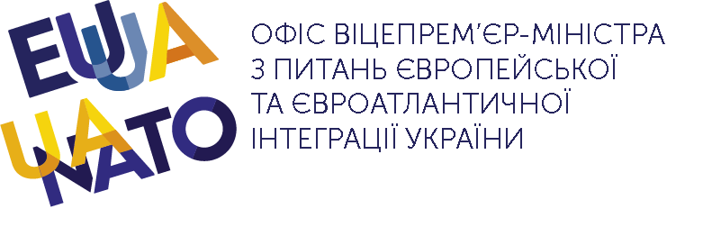
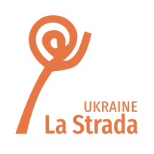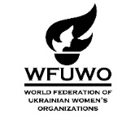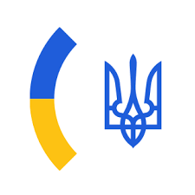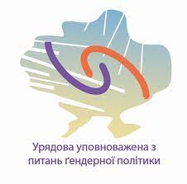
CSW 66 NGO Forum Parallel Event
Security from Gender Based Violence for Refugees and Migrants in Diaspora
March 21, 2022 8 - 10 am (EST/ NY)
The World Federation of Ukrainian Women’s Organizations is hosting a discussion of “Security from Gender Based Violence for Refugees and Migrants in Diaspora” as a parallel event to be held during the non-governmental forum of the 66th Session of the Commission of the Status of Women.
Even before 24 February 2022 when the Russian Federation opened its unprovoked war of annihilation against Ukraine, the security of migrants, displaced persons, and refugees was in critical focus as the covid pandemic, violent conflicts, and intensifying climate change-related disasters gripped the planet. Ukraine was experiencing these concerns deeply, not only by virtue of having a large labor migration that contributes to one of the largest diasporas of the world, but also because a significant portion of its population has been internally displaced by the war waged since 2014 by the Russian Federation in Ukraine’s east and in Crimea. Over the last 3 weeks, the political, socio-economic and environmental crises have compounded in severity. Russia’s all-out war on Ukraine has so far sent more than 3.2 million refugees, mostly women with small children, with children making up almost half of the refugee population.
It is widely acknowledged that migrants, IDPs, and refugees are among the most vulnerable populations with regard to gender-based violence. War exacerbates their vulnerability to all forms of violence, including sexual assault, rape used as a weapon of terror, and sexual exploitation in the context of prostitution and pornography.
Ukraine’s activist women have long addressed domestic violence, gender-based violence and trafficking of humans and have recently held wide meetings - including diasporan NGOs working in anti-trafficking since the late 1990s, and the World Federation of Ukrainian Women’s Organizations’ Commission on GBV, and North American anti-trafficking activists – in order to counter the threat of trafficking faced by girls, young women and mothers with small children moving from Ukraine into countries west of the border.
Those concerned with security of the refugees fleeing the Russian invasion of Ukraine are grateful to the European Commission for activating, on February 27, 2022, the Temporary Protection Directive which offers quick and effective assistance to Ukrainian nationals and their families. Activists are also standing firm on promoting Ukraine’s ratification of the Council of Europe Convention on preventing and combating violence against women and domestic violence (the Istanbul Convention). This convention, which has become the gold standard for the fight against domestic violence not only for Europe but for all regions, bolsters the legal framework providing security to citizens living and working within as well as beyond any one country’s borders.
The participants of this panel discussion are intergovernmental and non-governmental actors, and government officials who are concerned with refugee security and represent countries to which Ukrainian refugees are currently fleeing. They are asked to comment on the universe of concerns and practices that will help face this question of security against GBV for those in displacement and transit, including the importance of taking diaspora into account in governmental public policy.
The session will be held on Zoom, and will be conducted in English. To register for this CSW 66 NGO Forum Parallel Event please use the following link. https://us02web.zoom.us/meeting/register/tZUqf-msqT0qHNb-Yv-qImAiG5SZU4C2EufP
Program
Greeting Martha Kebalo, Main Representative to UN/ECOSOC for World Federation of Ukrainian Women’s Organizations
Moderator Mariana Yevsyukova, WFUWO Representative to UN Women’s Ukrainian Women’s Initiative in UAE
Kateryna Levchenko, Ukraine Government Commissioner for Gender Policy, Vice-Chair of COE Gender Equality Commission, and Ukraine’s candidate to CEDAW 2023-2026, co-chair of Ukraine official delegation to CSW 66
Åsa Regnér UN WOMEN, Deputy Executive Director for Policy, Programme, Civil Society and Intergovernmental Support
Maria Grazia Giammarinaro, Former UN Special Rapporteur on trafficking in persons, especially women and children
Olga Revuk, Deputy Minister of Social Policy of Ukraine for European Integration
Olesia Bondar, Director, Ukrainian Women’s Fund, Kyiv Ukraine
Yuliia Anosova, lawyer, La Strada Ukraine
Lubov Maksymovych, Director, Women’s Perspectives, Lviv, Ukraine
Oleksandra Faryma, President of WFUWO Commission against GBV (Netherlands)
Suzanne Hoff, International Coordinator, La Strada International (Netherlands)
Joanna Garnier, Vice President, La Strada Foundation against Trafficking (Poland)
Myroslava Keryk, President, Our Choice Foundation, Poland
Discussion, Q & A

